

**Table of Contents**

**IFR Clearance Delivery**

**VFR Clearance**

**Taxi Instructions**

**Takeoff Instructions**

**Landing Clearance**

**ILS Approach Plates**

**Approach/Departure Controlling**

**Departure Controlling**

**Approach Controlling**

**VFR Flight Following**

**IFR Clearance Delivery**

Clearance Delivery is the Air Traffic Control position where flight plans are originated and opened. Delivery is in charge of giving initial aircraft altitudes, headings, frequencies, and squawk codes. This position intensely works hand-in-hand with Flight Strips. You’ll need to have a good handle on airspace, departure procedures (SIDs), and phraseology to perform this position. If you do not understand any of these before training, your ATC instructor can train you or point you in the right direction of movement. An IFR Clearance Delivery sequence would sound similar to this:

**Pilot:** Atlanta Clearance, American 1907 (pronounced: *nineteen-oh-seven*), looking to open up IFR to Kennedy International Airport.

**Clearance:** American 1907, Atlanta Clearance, your flight plan is on request, standby, you’re number

One.

**Pilot:** number one, 1907.

*During this time, clearance will gather the initial heading, initial altitude, cruise altitude, departure frequency, and the squawk assignment for the aircraft. The initial altitude given to aircraft on an IFR flight plan is based on a standard determined by the airspace classification. The altitudes are as follows:*

|  |  |
| --- | --- |
| **Airspace** | **Altitude** |
| Bravo | 5,000 |
| Charlie | 4,000 |
| Delta | 3,000 |

*Atlanta is a Bravo airspace, which means we’ll give American 1907, 5,000. The Clearance Delivery transmission follows this template:*

*\*Callsign* *Airport Clearance\** you are cleared to *\*destination airport\** as filed. After departure, fly runway heading (or SID), climb and maintain _________, expect *\*altitude\** one-zero minutes after departure,

Departure frequency is __________, squawk _________

*Once clearance delivery has gathered the necessary information to give the clearance:*

**Clearance:** American 1907, I have your flight plan. Advise when ready to copy

**Pilot:** Ready to copy, 1907

**Clearance:** American 1907, Atlanta Clearance, you are cleared to the Kennedy airport as filed, after departure fly runway heading, climb and maintain 5000, expect flight level 3-1-0, 1-0 minutes after departure, Atlanta Departure is on 1-2-5-point-7, squawk 3-4-0-7

**Pilot:** American 1907, cleared to Kennedy international airport as filed, after departure fly runway heading, climb and maintain 5,000, expect flight level 3-1-0, 1-0 minutes after departure, departure on 1-2-5-point-7, squawk 3-4-0-7

*After the aircraft has correctly read back the clearance, you must clear them for push and start if they are at a gate.*

**Gate Aircraft EXAMPLE:**

P a g e 2 | 14

American 1907, read-back correct, cleared for the push and start face South, (depending on which runway is active), expect runway ______ for departure, contact me (or ground controller) on *frequency* for taxi.

**General Aviation Aircraft EXAMPLE:**

Learjet 4-Sierra-Papa, read-back correct, contact me (or ground controller) on *frequency* for taxi.



P a g e 3 | 14

**VFR Clearance (At Bravo & Charlie Airspaces)**

When a VFR aircraft is in a Bravo or Charlie airspace looking to depart the airspace, they can choose to open a VFR flight plan with clearance delivery. Due to the high traffic flow in and out of these airspaces, VFR aircraft have less leeway and freedom. There are many similarities between an IFR and VFR Clearance that you’ll notice. While VFR aircraft won’t typically be flying to a specific fix after departure as an IFR aircraft would, Delivery needs to know an approximate direction of Flight from VFR aircraft. Delivery also needs to know the cruise altitude of the flight. Once this information has been gathered from the pilot, the Delivery controller gives the pilot an altitude that they need to stay at or below when inside the Bravo or Charlie airspace limits, then the departure frequency, then a squawk code.

**EXAMPLE:**

**Pilot:** Good Afternoon Atlanta Clearance, Cessna 1234B

**Clearance:** Cessna 1234B, Atlanta Clearance

**Pilot:** Clearance, Cessna 1234B is at the general aviation ramp, we’re a Cessna 172, VFR 6,500 to Newnan-Coweta Airport Charlie-Charlie-Oscar (CCO).

**Clearance:** 1234B, say on course heading for the destination. *(You’re looking for the heading they’ll fly to get to their destination.)*

**Pilot:** 2-2-6 on course to Charlie-Charlie-Oscar, 1234B

**Clearance:** Roger, standby

**(During this time, you, as the Clearance controller, should gather the information that you’ll be giving them. You’ll need the initial altitude that they should maintain within the Bravo or Charlie airspace, the departure frequency, and a VFR squawk code to give them.)**

**Clearance:** 1234B, we have your flight plan. Advise when ready to copy.

**Pilot:** Ready to copy, 1234B

**Clearance:** 1234B maintain VFR at 2,000, expect requested altitude 1-0 minutes after departure, departure frequency is one-two-five-point-seven, squawk 1-2-0-1.

**Pilot:** 1234B VFR 2,000, expecting 6,500 in 1-0 minutes, departure is one-two-five-point-seven, squawk 1-2-0-1.

P a g e 4 | 14

**No VFR Traffic Patterns in Bravo airspaces. Airports on RealFsx that are Charlie or Bravo airspaces are:**

|  |  |
| --- | --- |
| **Bravo Airspaces** | |
|  |  |
| **Denver (KDEN)** | **Salt Lake City (KSLC)** |
|  |  |
| **Las Vegas (KLAS)** | **Phoenix (KPHX)** |
|  |  |
| **Los Angeles (KLAX)** | **San Francisco (KSFO)** |
|  |  |
| **San Diego (KSAN)** | **Atlanta (KATL)** |
|  |  |
| **Charlotte (KCLT)** | **Honolulu (PHNL)** |
|  |  |
| **Orlando (KMCO)** | **Tampa (KTPA)** |
|  |  |
| **Miami (KMIA)** | **Seattle (KSEA)** |
|  |  |
| **Victoria (CYYJ)** | **Kennedy (KJFK)** |
|  |  |
| **Boston (KBOS)** | **LaGuardia (KLGA)** |
|  |  |
| **Newark (KEWR)** | **Philadelphia (KPHL)** |
|  |  |
| **O’Hare (KORD)** | **Houston G Bush (KIAH)** |
|  |  |
| **Dulles (KIAD)** | **Reagan (KDCA)** |
|  |  |
| **Baltimore (KBWI)** | **Pittsburg (KPIT)** |
|  |  |
| **Dallas Ft Worth (KDFW)** |  |

**Charlie Airspaces**

|  |  |  |
| --- | --- | --- |
| **Ontario (KONT)** | **Savannah (KSAV)** |  |
|  |  |  |
| **Birmingham (KBHM)** | **Chattanooga (KCHA)** |  |
|  |  |  |
| **Charleston (KCHS)** | **Kahului (PHOG)** |  |
|  |  |  |
| **Jacksonville (KJAX)** | **Daytona Beach (KDAB)** |  |
|  |  |  |
| **Fort Lauderdale (KFLL)** | **Reno (KRNO)** |  |
|  |  |  |
| **Sacramento (KSMF)** | **San Jose (KSJC)** |  |
|  |  |  |
| **Monterey (KMRY)** | **Fresno (KFAT)** |  |
|  |  |  |
| **Vancouver (CYVR)** | **Portland (KPDX)** |  |
|  |  |  |
| **Spokane (KGEG)** | **Albany (KALB)** |  |
|  |  |  |
| **South Bend (KSBN)** | **General Mitchell (KMKE)** |  |
|  |  |  |
| **Gerald R. Ford (KGRR)** | **Dane County (KMSN)** |  |
|  |  |  |
| **Atlantic City (KACY)** | **Richmond (KRIC)** |  |
|  |  |  |
| **San Antonio (KSAT)** | **Lubbock Preston Smith** |  |
| **(KLBB)** |  |
|  |  |
| **Will Rogers (KOKC)** | **Toronto (CYYZ)** |  |
|  |  |  |

**Taxi Instructions**

*Callsign* *Airport Ground* runway ____ taxi via ___________

**EXAMPLE:**

American 1907, Atlanta Ground, runway 2-7-Right taxi via Lima 4 and Mike

P a g e 5 | 14

**Takeoff Instructions**

*Callsign* *Airport Tower* winds ____ @ ____, runway ____ cleared for takeoff

**EXAMPLE:**

American 1907, Atlanta Tower, winds 270 at 8, runway 2-7-Right, cleared for takeoff

*Aircraft looking to remain in the patterns handled differently. They will remain in the airspace (1,000 feet above airport elevation) and contact the tower when midfield downwind. There is no such thing as an IFR traffic pattern. While some may file an “IFR traffic pattern”, they are truly looking for radar vectors around the airspace. It is suggested that you, as the controller, assign the aircraft a fix to fly to where they can then get vectored back to the airport. This will be explained during your ATC training.*

**Standard Traffic Pattern EXAMPLE:**

Cessna 1-7-2-Sierra-Papa, Lindbergh Tower, winds 0-9-0 at 6, runway niner, cleared for takeoff, report midfield.

**Non-Standard Traffic Pattern EXAMPLE: (Right Traffic)**

Cessna 1-7-2-Sierra-Papa, Lindbergh Tower, winds 2-7-0 at 7, runway two-seven, cleared for takeoff, fly right-traffic, report midfield.

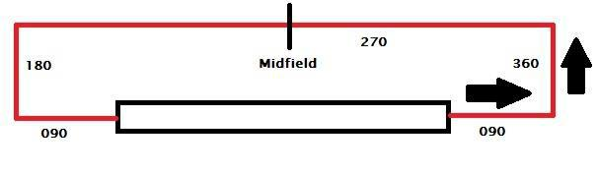

*Aircraft must contact you midfield because upon contact. You can extend downwind; should there be traffic on the final. If there is no traffic on final when they reach your midfield, you may clear them to land or for a touch-n-go or for “the option”; meaning they have the choice to do either. Stay away from having the pilot contact you on base. It gives you no time or chance to get them clear of the approach path should an aircraft arrive.*

**EXAMPLE:**

**Pilot:** Lindbergh Tower, Cessna 1-7-2-Sierra-Papa is midfield left-downwind runway niner for touch-n-go.

**Tower:** Cessna 1-7-2-Sierra-Papa, winds calm, altimeter two-niner-niner-two, runway niner, cleared for the option.

P a g e 6 | 14

**Landing Clearance**

*Aircraft inbound on an approach will contact the tower once the Approach Controller hands them over to you.*

*\*Callsign* *Airport Tower\** winds ____ @ ____, runway ____ cleared to land.

**EXAMPLE:**

American 1907, Atlanta Tower, winds 2-7-0 at 6, runway 2-7-Left, cleared to land.

*After an aircraft lands, you must tell them which direction to exit off the runway. General Aviation aircraft should go to general aviation parking, and Airlines should go to the terminal unless otherwise specified. A good rule of thumb is to wait 3 seconds after the aircraft has put its nose gear on the ground. You don’t ever want to contact an airplane when it’s on short final as this is a crucial part of the flight.*

**EXAMPLE:**

**Tower:** American 1907, turn right next intersection, contact ground point niner.

*Most Ground frequencies begin with “121” so you can drop the “121” and say “point ____”. Per*

*the example above, the actual ground frequency is “121.90”…but the ground controller said “Ground point niner”. It all means the same thing, but a shorter way to say it. If the ground frequency is something other than 121.___, you must say the entire frequency.*

P a g e 7 | 14

**ILS Approach Plates**

*You must have the approach plates in your possession when acting as ATC. These plates are available at* [*faa.gov*](http://aeronav.faa.gov/digital_tpp.asp?ver=1303&eff=03-07-2013&end=04-04-2013) *,* [*airnav.com,*](http://www.airnav.com/) *or* [*skyvector.com*](http://www.skyvector.com/) *by simply filling in the ICAO code for the airport and clicking search. You will need to determine what altitude they need to cross the final approach and descend them as required.*

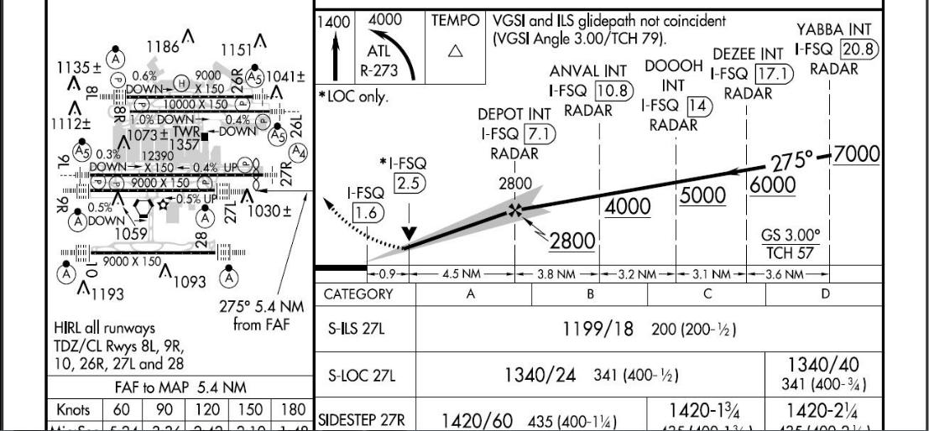

*Looking at the profile view of the ILS 27L approach for ATL, you can see many different altitudes where the aircraft can establish on the approach (2800, 4000, 5000, 6000, 7000). First, find the Final Approach Fix (FAF) at DEPOT at 2,800 feet. For this example, let’s use ANVAL at 4000. . . if we wanted them to descend and maintain 4,000 feet, we would need to vector them for a final approach of at least 10.8 miles. This can be seen under “ANVAL INT”. You would need to locate the ANVAL Intersection on the radar screen and make sure they cross that fix at 4,000 feet. If they are above 4,000 feet at the ANVAL Intersection, they will not establish on the glideslope unless they descend to 2,800 feet by the time they cross the DEPOT Intersection, which is 7.1 miles from the runway. If the aircraft does not make it down to 2,800 by the time he reaches the DEPOT Intersection, you will have to re-vector him. For this example, let’s give them a 12 mile final. We know that at 10.8 miles, they’ll need to be at 4,000 feet. If we give them a 12 mile final, we’ll want them at 4,000 feet.*

*Once they’re down at 4,000 on their base leg, you’ll be ready to give them the next portion of an ILS approach known as “the dogleg”. This next heading is a maximum of 30 degrees to the right/left of the runway heading. This means their next heading can be 280, 290, or 300 for this approach. If they were right traffic for runway 27, the dogleg would be 260, 250, or 240. Since we’re using the left-hand traffic pattern, we’ll use 2-9-0. For larger/faster aircraft, you’ll want to turn them earlier to this dogleg than you would a King Air or Cessna. It’ll take some practice to get it right. An example of this approach's phraseology is below in the approach control section.*

*This is not an easy task and will improve with practice. There is a lot of information above, but you’ll begin to understand the concepts if you review them enough. If there is a TRACON controller online, they will take care of these vectors.*

P a g e 8 | 14

**Approach/Departure Controlling (Terminal Radar Approach Control or “TRACON”)**

*Approach and Departure controllers are TRACON (Terminal Radar Approach Control) and handle aircraft around the airport or “terminal airspace”. Departure controllers take IFR aircraft from about 500 feet up to the ceiling of their airspace, at which point they hand them over to Center controllers or ARTCCs (Air Route Traffic Control Centers). Centers bring aircraft up to their cruise altitude. Approach controllers take airplanes from the floor of the Center’s airspace and descend them down into their TRACON airspace, at which point they vector IFR aircraft to their final destinations. VFR aircraft remaining in the pattern at the airport will NOT contact departure; they will stay on the tower frequency.*

*Another possible duty of TRACON is Flight Following. A VFR aircraft may request flight Following from TRACON, and the controller can choose to provide it or not depending on the current workload. Flight Following means the controller will alert aircraft of traffic around them. Controllers providing Flight Following do not give vectors to the VFR traffic. Once the VFR aircraft is near their destination or leaves their airspace, the controller will “Terminate Radar Services”. More detail on flight Following to come.*

*When using Flight Strips, Approach controllers select “Approach” and Departure controllers select “Departure”; if you plan to handle both arrivals and departures, select “Radar,” which is the equivalent of “TRACON”. Departure controllers will receive strips from the tower and pass them to Center controllers.*

*Approach controllers will receive strips from the Center and pass them to the tower as the aircraft vectors onto their approach.*



P a g e 9 | 14

**Departure Controlling**

*As stated above, Tower controllers hand IFR aircraft to Departure or “TRACON” when climbing through around 500 feet. Departing IFR aircraft should contact departure with their altitude and what altitude they’re climbing to.*

**EXAMPLE:**

**Pilot:** Atlanta Departure, American 1907 with you through one-thousand-two-hundred (1,200) climbing five-thousand. (5,000)

**Departure:** American 1907, Atlanta Departure, radar contact, continue climb five-thousand. (*or higher altitude if necessary)*

*Departure controllers must say “Radar Contact” when they have seen the aircraft on the radar and have cross-referenced their altitude. What this means is, the moment the departure controller hears “American 1907”, he should find the aircraft on the radar and immediately look at their current altitude. When the pilots say “climbing through 1,200”, and the radar shows they are at 1,200. That means the transponder provides the correct information to the radar. If a different altitude shows on the radar screen, controllers should verify what altitude the aircraft climbed through. As long as the radar screen information is correct, the controller has proper “radar contact.”*

*Some pilots may forget to tell the controller what altitude they are climbing through on initial contact.*

*Such instances should handle like this:*

**EXAMPLE:**

**Pilot:** Atlanta Departure, American 1907, with you.

**Departure:** American 1907, Atlanta Departure, radar contact, I show you climbing through one-thousand-two-hundred, continue your climb to 5,000, runway heading.

**Pilot:** Continue climb to 5,000 runway heading, American 1907.

*If for whatever reason, the altitude that you show them climbing through is not the altitude they show on their altimeter, the pilot should alert you after your transmission. The controller would ask the pilot to “recycle” the transponder or turn it off in the real world.*



P a g e 10 | 14

**Approach Controlling**

*Approach Control takes aircraft from the floor of the Center’s airspace down into their Terminal airspace and vector them for the active approach. Controllers need to understand the specifications of different aircraft when vectoring them. (i.e., a larger/faster aircraft will need more space and time to turn and descend than a slower/smaller aircraft.)*

*Let's assume that “American 1907” is a 737-800 inbound to Atlanta at 11,000 feet. We plan to vector the aircraft, which is currently 40 nautical miles (nm) to the south, to ILS approach runway 27L. As learned earlier, the Final Approach Fix for that runway is DEPOT at 2,800 feet. Descending a turbine aircraft too early reduces its efficiency and causes noise pollution to the surrounding communities. At the same time, you don’t want to wait too long and risk having that aircraft too high on the approach. There is a great, useful tool that calculates descent here. With some practice, controllers will understand aircraft characteristics and know when to descend aircraft. A controller can ask a plane to “expedite descent”, but such instruction should be avoided. The blue arrow will represent American 1907.*

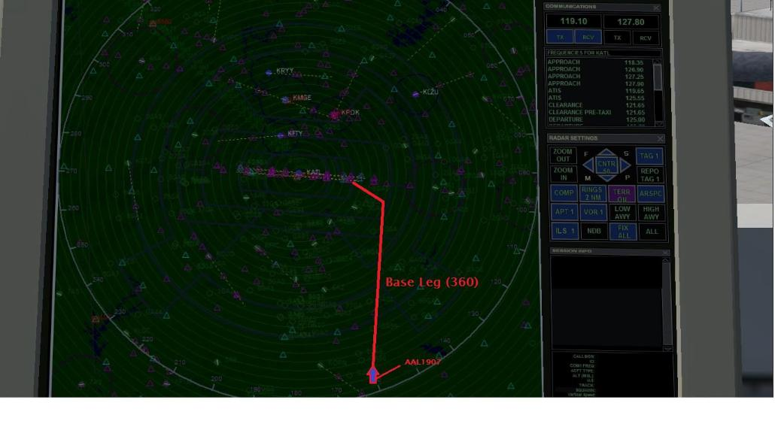

*With American 1907 40nm out at 11,000, we can begin to “step” them down to the altitude we want them to establish on the localizer. If we plan to give them a 12nm final as depicted in the diagram above, we’ll need to get them down to 4,000 feet. Rather than descending them straight to 4,000, we may want to descend them to 7,000 feet first and then continue their descent down to 4,000 later.*

**EXAMPLE:**

**Pilot:** Atlanta Approach, American 1907, with you at one-one-thousand.

**Approach:** American 1907, Atlanta Approach, roger, fly heading 3-6-0, descend and maintain 7,000, expect vectors ILS runway 2-7-Left, Atlanta Altimeter two-niner-niner-two.

**Pilot:** Heading 3-6-0, down to 7,000, expect vectors ILS runway 2-7-Left, altimeter two-niner-niner-two, American 1907.

P a g e 11 | 14

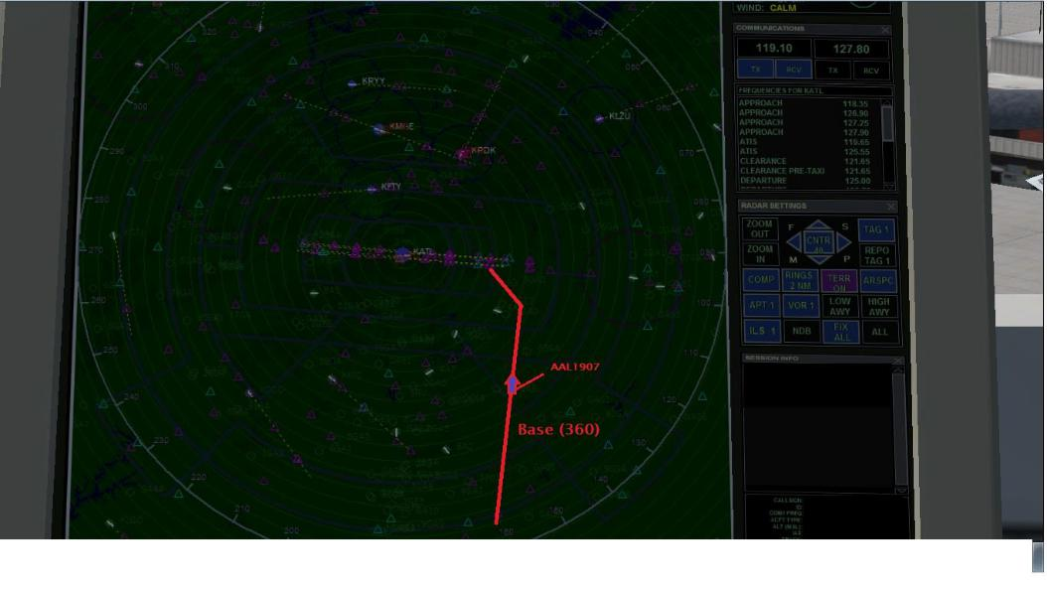

*American 1907 is now level at 7,000 feet and still on base for runway 2-7-Left. The next step is to vector them on the dogleg for the localizer. (That was explained in detail earlier) At this point, you can continue their descent down to 4,000 feet.*

**EXAMPLE:**

**Approach:** American 1907, descend and maintain 4,000.

**Pilot:** Down to 4,000, American 1907

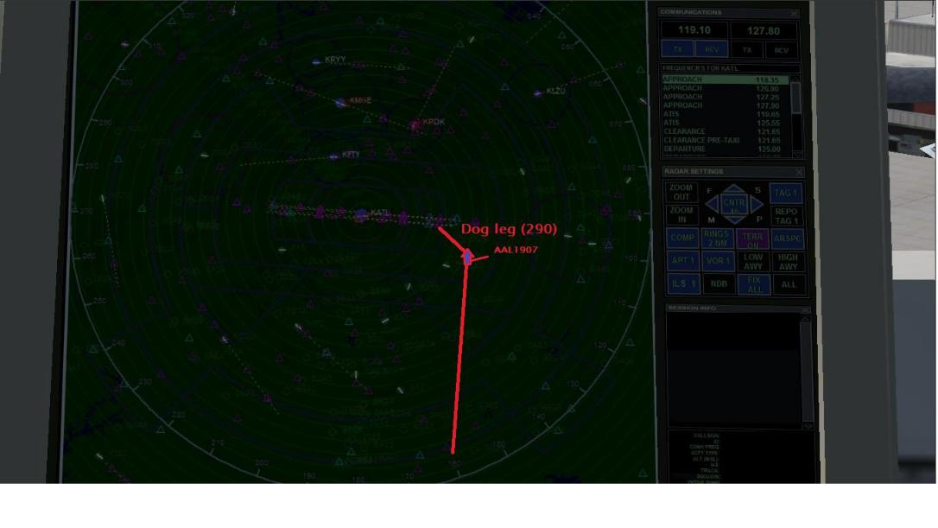

*American 1907 is now at 4,800 feet, descending to 4,000 and is ready for its dog leg turn. Remember that we want them to establish at ANVAL at 4,000 feet (in this example) Using the mile rings on the radar screen, determine American’ 1907’s distance from ANVAL.*

P a g e 12 | 14

**EXAMPLE:**

**Approach:** American 1907, you’re 8 miles southeast ANVAL, turn left two-niner-zero, descend and maintain 4,000 until established; you’re cleared ILS runway 2-7-Left approach.

**Pilot:** Turn left two-niner-zero, descend and maintain 4,000 until established, cleared ILS runway 2-7-Left, American 1907.

*Once the aircraft establishes on the localizer, send the aircraft over to the tower frequency.*

**Approach:** American 1907, contact Atlanta Tower 119.1 g’day.

**Pilot:** 119.1, American 1907, g’day

*Pass their flight strip to the tower controller because the tower will now control this aircraft.*



P a g e 13 | 14

**VFR Flight Following**

Flight following is a service that the TRACON or Center (Air Route Traffic Control Center) is not obligated to provide to VFR aircraft flying in their airspace. A VFR aircraft may request “Flight Following” from a controller who will give the aircraft traffic reports. As stated, the controller has the right to deny this service should there be too much traffic in the airspace to accept any more responsibility. With that said, it’d take a lot of traffic on the controller's scope to deny this service. Flight following has its positives for both the pilot and the controller. There is an increase in safety for the pilot as regular contact with air traffic control means the controller will look after the aircraft and ensure separation from other targets. For the controller, flight following provides them with information on the aircraft’s type and destination. When contact is not established between a VFR aircraft and an air traffic control station, controllers must vector aircraft clear of the aircraft target. While the transponder may show the plane at 3,000 feet, legally, the controller cannot assume the plane is at 3,000 feet. It is not until the pilot reports to the tower that they are at 3,000 feet that the controller can now affirm the aircraft’s transponder is sending the correct information. Much like a departure controller communicating with a plane on an IFR flight upon departure, “Radar Contact” is established and said to this aircraft. With the establishment of “Radar Contact”, the controller can now vector traffic at 4,000 feet over the aircraft at 3,000 with the legal 1,000 feet of vertical separation achieved. A flight following request sequence would be similar to the following:

**Pilot:** Atlanta Approach, Cessna 1234B is with you at 2,000. Cessna 172. VFR 6,500 to Newnan-Coweta Airport, Charlie-Charlie-Oscar (CCO), request flight following.

**TRACON:** Cessna 1234B, Atlanta Approach, squawk 1-2-0-1 and ident.

**Pilot:** squawk 1-2-0-1 and ident, 1234B.

*During this time, the controller finds the aircraft on their scope and determines its position to the closest station; Typically, this is an airport. Let’s assume 1234B is 7 miles west of Atlanta Hartsfield.

**TRACON:** Cessna 1234B, radar contact 7 miles west of Atlanta Hartsfield, altimeter two-niner-niner-two, good afternoon.

**Pilot:** two-niner-niner-two, 1234B, good afternoon.

*Once the aircraft is approximately 10 miles from its destination, the controller will terminate their radar services based on whether the aircraft has the destination airport insight or not. This sequence would sound similar to the following:

**TRACON:** Cessna 1234B, Newnan-Coweta is at your 12 o’clock, 1-0 miles, report insight.

**Pilot:** We have the airport, 1234B.

**TRACON:** Cessna 1234B, radar services terminated, squawk VFR, frequency change approved, enjoy your day.

**Pilot:** Squawking VFR, thanks for your services, 1234B.

*Squawking VFR in the United States is 1-2-0-0. Should a pilot not understand “squawk VFR”, simply state, “squawk 1-2-0-0”.

P a g e 14 | 14